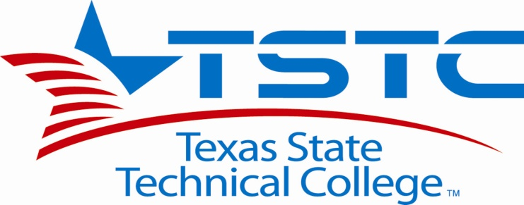
RFP1219W
Title: Dugger Building Painting Project
Addendum #1
Posted Date: 011-14-011
Correction for Purpose of the request of Proposals 1.1
The Purpose for request of proposals 1.1 is changed to the following. The Texas State Technical College Waco is requesting Competitive Sealed Proposals for material, labor and equipment for painting of classroom walls, classroom hallways and as an alternate the painting of the office hallways of the Dugger Bldg. located on the TSTC Waco Campus at the Texas State Technical College, located at 3801 Campus Dr. Waco, TX 76705, as described within the Scope of Work specification.

Please sign and date below and attach addendum to the bid package submitted.

I, by signing below acknowledge receipt of the posted addenda, and understand that it becomes part of the bid package for submission.

Vendor Name:___________________________________________

Signature: ______________________________________________
Date: _________________________________________________

